Introduction
This document outlines the design, implementation, and testing of the developed distributed system. The distributed system has been designed to enable the monitoring of conditions of a large greenhouse using motorised buggies fitted with temperature, humidity, and light sensors. This solution is an alternative to conventional methods where arrays of sensors are typically used to monitor conditions in large greenhouses.
The buggies can be accessed remotely allowing the users to manually control or configure the buggy. Additionally, the user can set the buggy to autonomous mode in which the buggy will autonomously drive around the area by utilising light sensors and an ultrasonic sensor and collect data about the conditions in the greenhouse which will then be relayed back to the user. The distributed system uses a server to allow multiple users to interact with buggies available on the network. A detailed set of objectives for the system is outlined below.

Objectives
- The system has to be capable of allowing multiple users and multiple buggies connected to the network to interact reliably without interference between users or major drop in performance.
- The system should be reliable. Communication: Requests/data should arrive to its destination and loss of connection between the server, users and buggies should be handled to prevent crashes or unpredictable system behaviour.
- The buggy should send back environmental data such as light levels, temperature, and humidity. Any other necessary information should also be sent back. All the information is to be sent back to the connected controller to be displayed on its GUI.
- The controller should be able to control the movement of the buggy and configure it if necessary.
- Add Autonomous mode. In autonomous mode, the buggy will send data back to the connected controller client automatically and periodically. Additionally, the buggy will be able to move around autonomously avoiding obstacles in its way.

Design

Distributed System Components
The system is comprised of and distributed across four components: The Server, Controller Client, ESP32 and Arduino Mega. Figure 1 depicts the relation between these components. The system uses TCP/IP protocol to send requests between the server, controller clients and buggies. The TCP/IP protocol has been chosen due to features such as:
- Guarantee of delivery – ensures that data will be delivered as long as there is a connection.
- Order of delivery – Ensures that the data is delivered in the same order it was sent.
- Error Correction – Utilises checksums to ensure that the data was not corrupted during the transmission process.
Despite being slower than UDP due to the extra data the protocol transmits, it offers the reliability that that satisfies the communication reliability requirement of the system.
The requests only carry ‘ready to use’ data. This means that any processing of the data is done on the hardware platform the data originated from. This decision was made to utilise the computing power of all devices in order to distribute the workload and not overload any one component. Additionally, data that has already been processed before transmission is smaller in size and therefore latency between transmission and delivery of the information will be reduced.
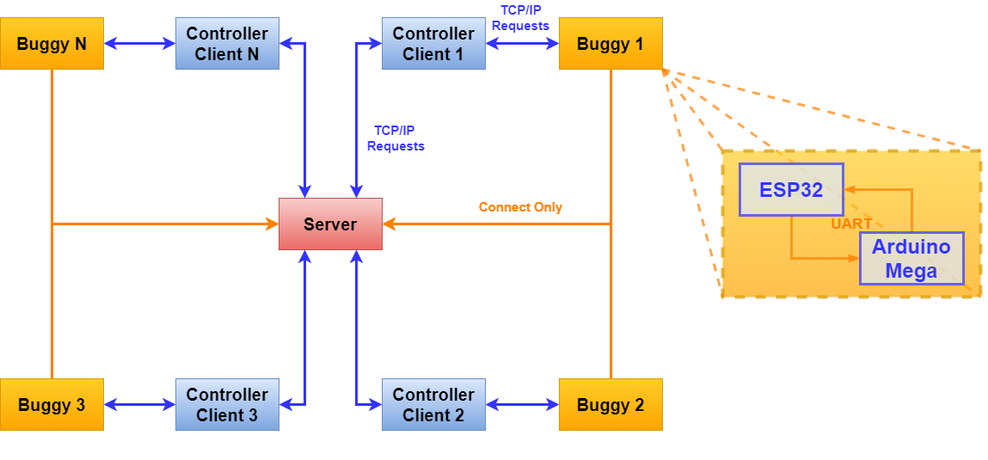
Figure 1:Connections between the components of the distributed system.

The Server
In order to allow multiple users and buggies to interact with each other, a server has been created for the controller clients and buggies to connect to. By having a server that all buggies and users connect to, awareness of all clients present on the network can be established. The server can then relay this information back to the controller clients which can then choose a buggy they would like to connect to.
Aside from maintain awareness of the connected clients, the server keeps track of the connections between controller clients and buggies and provides permission for controller clients to connect to a buggy. Because the server keeps track of the aforementioned information it prevents multiple client connections to a single buggy which prevents control contention.

Controller Client
The controller client is a graphical user interface utilised by the user of the system to connect and interact with the buggy and the server. The controller client provides the interface through which the user can control and interact with the buggy in three different modes. These are the ‘Manual’ mode, ‘Configuration’ mode, and ‘Autonomous’ mode.

Manual Mode
Manual mode allows the connected user to control the buggy. The user can move the buggy to a desired location and request environmental data from that location.

Configuration Mode
In this mode, the user can configure the following parameters to affect how the buggy operates.
Autonomous Mode Data Transmission Frequency – This configuration option allows the user to select how often the buggy sends data back to the user in Autonomous mode. A finer map of environmental conditions can be produced based on need.
Buggy Speed – Allows the user to select the speed at which the buggy can move. Finer motion can be achieved if the buggy moves slower.
Maximum Object Distance – Allows the user to set the maximum distance between the buggy and the obstacle before the buggy tries to avoid it in Autonomous mode. The slower the buggy speed, the larger the distance should be to allow the buggy space to avoid the obstacle.
Difference in Light Intensity – Allows the user to set the minimum difference between the readings of the Arduino LDRs before the buggy decides to move left or right. The LDRs are not perfect and there may be some differences in readings between the two even if the light intensity is identical. Allowing the configuration of the difference can prevent this effect from making the buggy turn if the intensity of light is the same. Additionally, setting this parameter can prevent the buggy turning at the smallest of changes in light intensity.

Autonomous Mode
In this mode the buggy moves around the greenhouse on its own, periodically relaying information about the conditions inside the greenhouse back to the user.

Buggy

ESP32
The ESP32 is a microcontroller that comes with integrated WiFi and is therefore used inside the buggy to allow connection to a network which in turn allows the buggy to connect to a server and a controller client to connect to the buggy.
The ESP32 also extracts data from the environment through the sensors interfaced to it and carries out appropriate computations on the data. Additionally, any information that the ESP32 receives from the controller client that is applicable to the Arduino Mega is relayed to the Arduino by the ESP32 using UART.
The ESP32 connects to the server to make it aware of the buggy’s presence. There is no communication between the server and the buggy after the connection is made.

Arduino Mega
The Arduino is equipped with an Arduino Motor shield which allows the buggy motors to be driven. The Arduino Mega is therefore responsible for driving the buggy. The Arduino is also equipped with two light dependent resistors (one to the right and one to the left of the buggy) and an ultrasonic module for use in the autonomous mode.
Any information that needs to be transmitted back to the controller client is first sent to the ESP32 over UART which then transmits the data back to the controller client. Because the ESP32 uses 3.3V logic level compared to the Arduino’s 5V logic level, a 3.3V-5V logic converter is used. Figure 2 depicts a detailed diagram of the hardware that comprise the buggy.
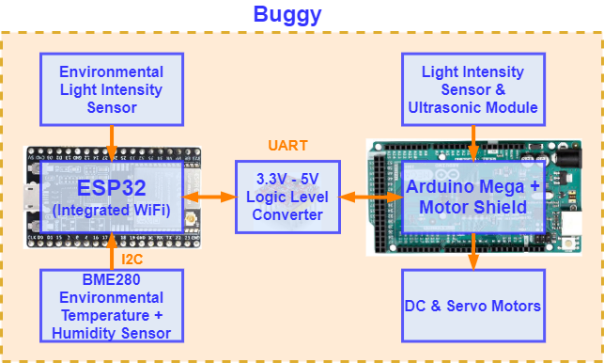
Figure 2: Hardware used in the buggy and hardware connections.

Choice of Sensors and Actuators
To provide the buggy with intended functionality and to ensure that the buggy is able to perform the intended tasks, the following sensors and actuators were chosen.
BME280 – Records temperature and humidity which are important parameters to monitor in a greenhouse to ensure optimal conditions.
LDR (Environmental) – Records the light intensity which is also an important parameter to monitor as light preferences of different plants vary.
LDR (Autonomous Mode) – The LDRs connected to the Arduino serve the purpose of guiding the robot through the greenhouse. Because there are no plants in the pathway, the light intensity would be higher than in places where plants are present. By comparing the light intensities from both, left and right LDRs that are attached to the Arduino, the buggy can make a distinction if it is straying from the correct path or not and correct its course. If a situation arises that the buggy cannot overcome, the user can always switch to manual mode and direct the buggy in the right direction.
Ultrasonic Module – The ultrasonic module serves the purpose of detecting nearby objects in front of the buggy in order to allow it to avoid collisions. The module is fitted to a servo motor to allow the buggy to move the module left and right to see and decide on which route to take depending on what the buggy detects to its left and right side.

Implementation
The programming languages used to develop the software for the distributed system were C++ and C#. C++ was used to program ESP32 and Arduino Mega. On the other hand, C# was used to develop the Controller Client and the Server which run on a Windows machine. Refer to Appendix A for a list of third-party libraries used to develop the distributed and interactive system.

Communication and Middleware
Because the mobile robot platform combined with sensors is akin to sensor networks, and the intended functionality does not require a vast variety of requests, a decision was made to implement 'primitive' based middleware where functions, built into each hardware platform of the system, are used to fulfil requests sent between the nodes in the network. The requests that are sent carry request identification to allow the target to recognise the type of request. Any data associated with the request that is required by the primitive is also sent. Figure 1 shows the generalised form of the request. Appendix B contains a full list of requests the distributed and interactive system uses, their description, and data composition. Appendix C provides a more detailed description of the data sent with each request.
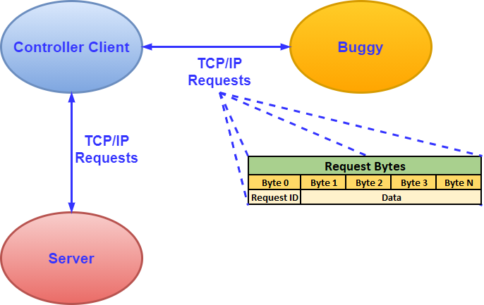
Figure 1: Generalised composition of a request used in the system and its format.

The handling of requests on each of the platforms can be generalised and represented by the diagram shown in figure 3. There are two exceptions:
- ESP32 and Arduino Mega do not use callbacks.
- Arduino Mega only maintains one-to-one communication with ESP32 over UART and it does not have other functionality or control over anything else apart from controlling the motion of the buggy. Therefore, it does not utilise features used on other platforms such as callbacks, threads or mutexes.
Figure 2 summarises features used by different platforms.
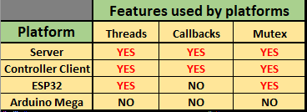
Figure 2: Features used by the four platforms.

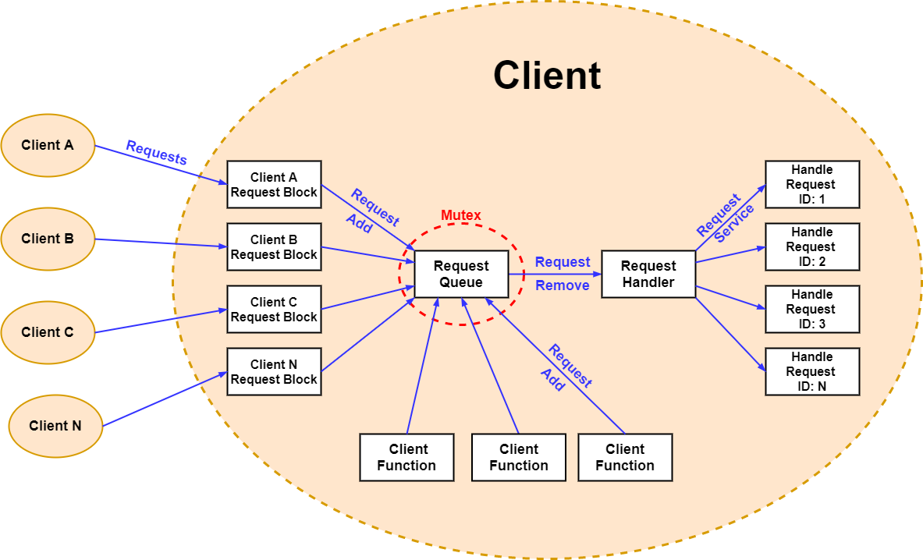
Figure 3: Diagram depicting how requests are handled.
When a request is being sent, be it a client to server request, this data is being received asynchronously using threads and callbacks as there may be other clients sending their requests to the server at the same time. Using this method of receiving (and sending) data between the server and the controller client means that the threads don't unnecessarily block waiting for data to arrive from a particular endpoint allowing the server or controller client to respond faster to any events that may occur.
ESP32 uses threads (called 'Tasks' in FreeRTOS) in conjunction with a mutex to handle incoming requests from Arduino Mega or the Controller Client.
Arduino Mega does not utilise thread functionality as it only communicates with ESP32 via UART and only controls the motion of the buggy. The microcontroller is fast enough to receive and send incoming requests as well as handle the requests and control the motion of the buggy in real-time.
Client Request Block
The client request block contains code to receive request data, sort the data into complete requests, and place the data into the request queue. Devices connected to each other with the purpose of communication each have such block. The number of blocks corresponds to the number of devices that a device is connected with. This was done to ensure that request data of different clients does not mix.
When the data has been sent by another device and is available to read, the recipient device reads the data into a FIFO buffer and then peeks the first byte in the buffer to determine what type of request has been sent. A check is then done to see if there is enough data in the buffer for the particular request to be carried out. If there are not enough bytes for the device to carry out the request, it simply waits for the rest of the request data to arrive. If there are enough bytes, the bytes (including the request type) are placed into the request queue in a thread safe way by utilising a mutex (in the case of Arduino Mega, request is just placed into the queue).
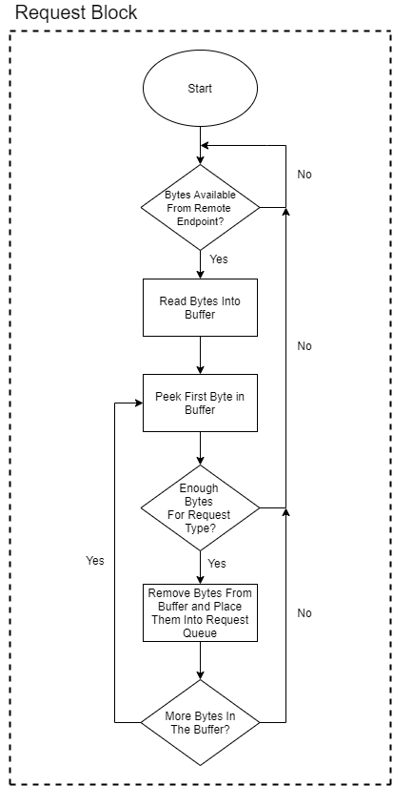
Figure 4: Flowchart depicting the process of adding request data to the request queue.
Request Queue
The request queue is a FIFO buffer that is accessed by the request block(s) to add requests to it and by the request handler to remove requests from it for servicing. The mutex is in place to ensure that the enqueueing and dequeuing of requests is done in a thread safe way to not corrupt the data (does not apply to Arduino Mega).
Request Handler
The request handler services requests that have been added to the queue in a FIFO fashion. The request handler first peeks the first byte in the buffer to see what kind of request it is and removes the appropriate number of bytes and passes this data to the function that will carry out the request. There is a dedicated function for majority of requests.
Client Function
Not only requests that come from other parts of the distributed system are serviced by the request handler. The handler also handles internal requests generated by various sections of the program running on the platform. Server and Controller Client often generate these internal requests to ensure that the functions are carried out in a thread safe manner as the code is executed on many threads and often multiple threads need access to resources with the intention of modification. ESP32 and Arduino Mega do not contain any functionality (except for servicing requests) that would require the use of the handler to service them in a thread safe manner.

Testing
A combination of Functional testing together with Black box testing been conducted to validate the system to see whether it satisfies the requirements, and to verify that system is error-free. These tests are performed at a high level and are mostly based on giving the system an input and seeing if the output is as expected. The list of all tests performed, and their results, can be found in the ‘Testing Plan and Results’ spreadsheet attached with the documentation (for better viewing layout), or in Appendix D. Majority of the system testing has been done through the controller’s GUI as the user input can be used directly to test the response of the distributed system and therefore verify whether the response given was the response that was expected. The link below contains a playlist of short videos of the tests that have been done to test the functionality of the system as evidence of the testing.
https://www.youtube.com/watch?v=krYwSQ-uNJ4&list=PLWMRUuReXHSUmGSNQ5i7BCqGFSJqFDjYJ&ab_channel=ZbigniewDruzbacki

Testing Results
Majority of functional tests performed have passed. However, there were some that uncovered effects that may have the potential to cause the system to crash. For example, the ESP32 Power failure test uncovered that the controller detects the disconnection with the ESP32 after a delay. Until the disconnection is detected, the user can still use the buggy controls to generate requests. Even though there are safety features in place to prevent the controller from crashing, the combination of controls may still cause a crash that the testing performed has not uncovered.
The Arduino Mega power failure test has failed. After it is powered on again, some of the configuration functionality that requires the Arduino Mega to send information back to the controller no longer works. This is due to the ESP32 not being able to recognise the requests sent from the Arduino Mega and therefore does not carry out its requests. This would be rectified if more time was permitted.

Evaluation
One of the biggest weaknesses of my distributed system is the reliance on correct data delivery. The reason for this is that I have not added code to handle cases where the data corruption occurs or when data is received out of order. The request handlers on each platform of my system handle data sequentially. This means that the handler will look at the first byte in the buffer (buffer that contains newly received data from the socket) and expect it to be the request identification byte which it uses to know how many bytes to extract from the buffer and place in the request queue. If data arrives out of order, the byte that the handler looks at will not be the request ID and likely not match any of the request IDs which will cause that part of the system to hang. Even if the byte matches any of the IDs, the data it will use to handle the request will be incorrect and might cause undefined behaviour. Or simply, the error will propagate onto other requests if the system does not crash or hang. If the request id is corrupted, the system won't be able to recognise the request and will not know what to do and therefore will hang. If the request id is corrupted and changed to any other request id, the situation is the same as described for data being out of order. Therefore, my system relies on TCP/IP to deliver the data correctly, making it too dependent on it. Given more time, I would upgrade my system to protect it against data corruption or data being delivered out of order.
My testing regime had too few tests that would test the system under challenging conditions. I therefore do not know the extent to which the system I have designed would be able to perform or whether I would be able to maintain control in unfavourable conditions. To verify whether or not my system can function in challenging conditions, White-box testing (to test inner-workings beyond the tests I have performed on the fly) in conjunction with some stress testing would need be carried out.
Taking the above into account, my system cannot fully guarantee system reliability under a wide range challenging conditions. However, the system does work under some controlled challenging conditions.
The ability of the system to handle multiple controllers and buggies has been satisfactory. The demonstration showed that multiple controllers and buggies can operate on the network, allowing users to reliably interact with buggies simultaneously, proving that my distributed system has the potential to be scaled. It would be preferable to carry out stress testing on the server to see how many buggies and controllers it can handle to see the extent to which the distributed system could be scaled.
Maybe add more about that interaction modes where successfully implemented and therefore the objects were met.

Suggested future work or improvement.
- Implement white-box testing to test inner workings of the system to ensure correct operation which will have a positive impact on the operation of the system under challenging conditions.
- Perform more stress testing to verify whether the system can handle operation under a variety of unfavourable conditions.
- Add more protection in the lower layers of the distributed system software. If the system’s correct functionality depends on data order, take extra care to ensure that the system can deal/cope with data corruption, or with scenarios where data ends up being out of order.
- Rectify the errors detected during testing.

Appendix A
List of libraries used to develop the distributed and interactive system.
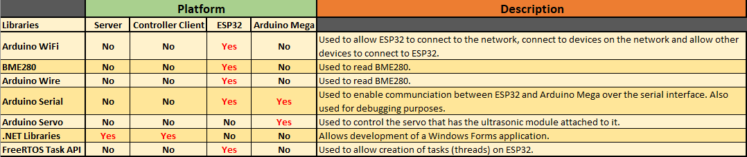

Appendix B
Complete list of requests used by the system and data composition of each request.
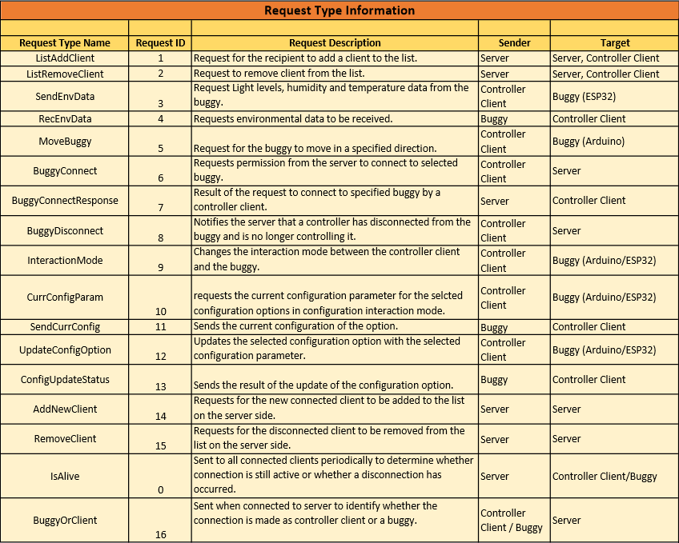
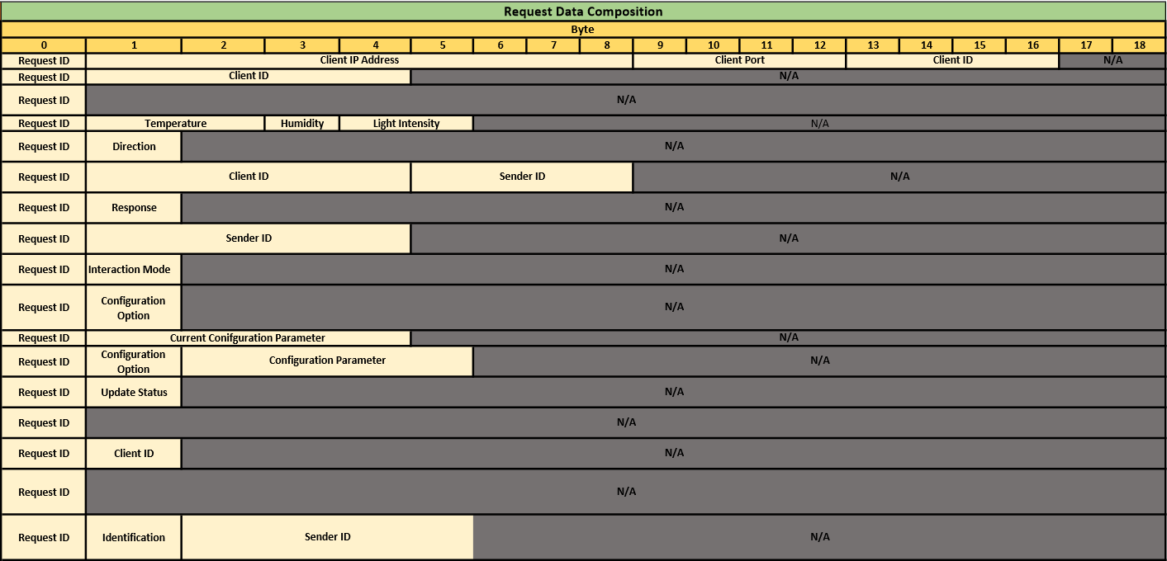

Appendix C
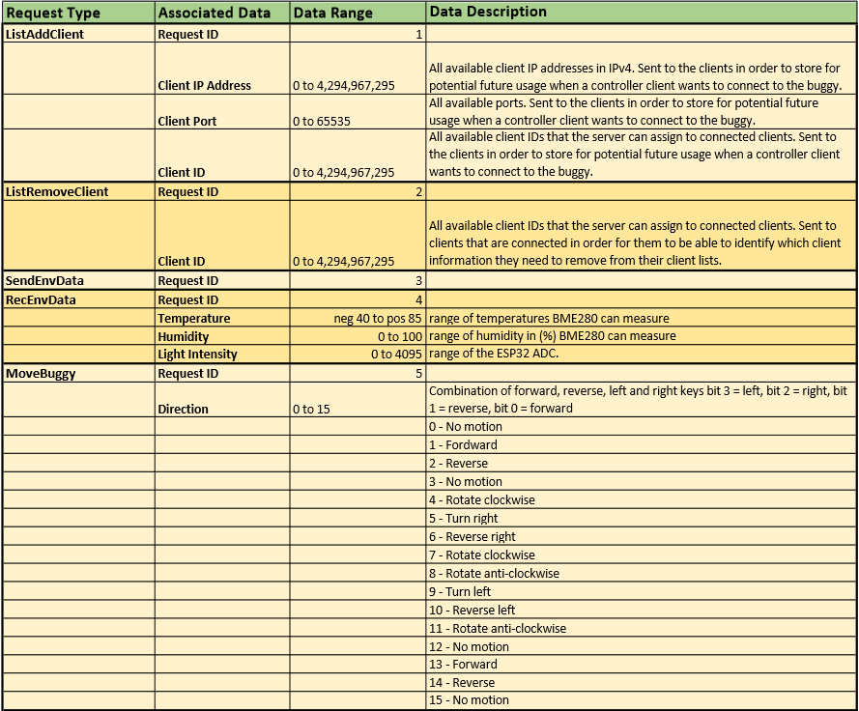
Detailed description of the data sent with each request.

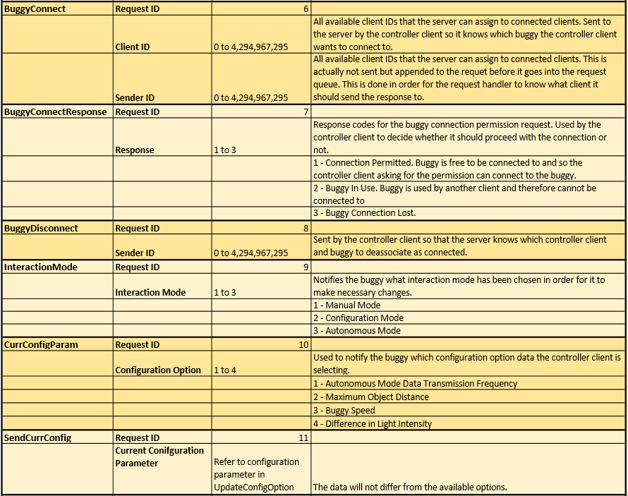

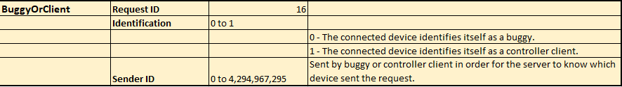
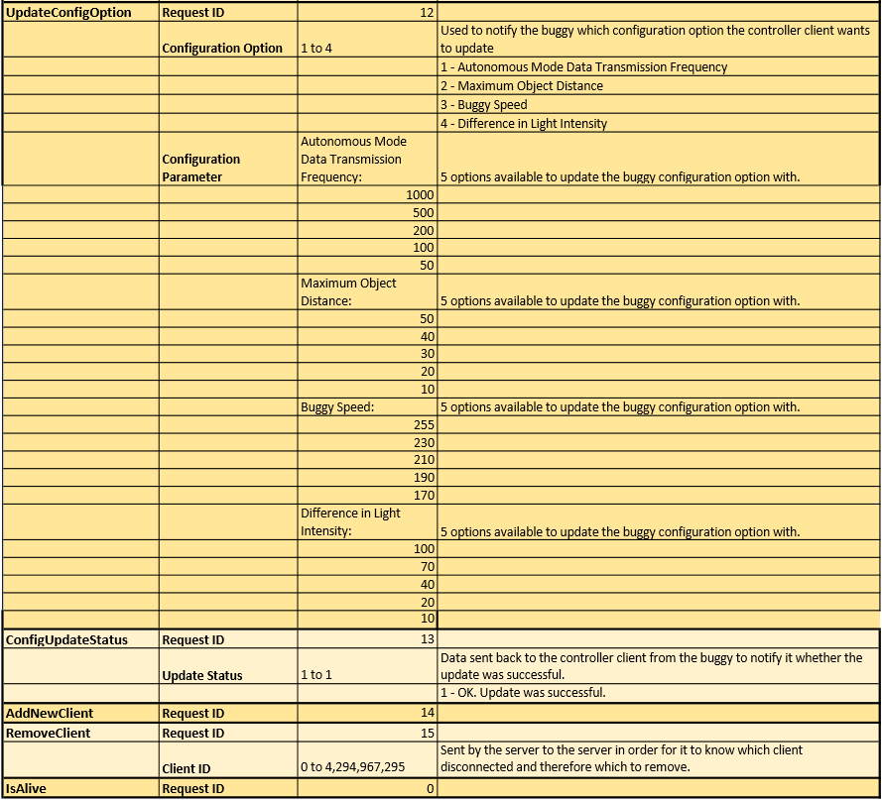

Appendix D
A table containing all the testing performed, description of the test, what was tested, the expected result and the actual result and whether the test has passed or failed and the date the test was performed.
